Software Engineering

**Final Report**

Version 1.0 - Dec 7, 2021

**Social Link**

Teamleader: Romeo Capozziello

Emmanuel Deshommes

Seydou Magassa

Naseem Davis

Eric Bialczak

Olmann Pauyo

Submitted in partial fulfillment of the requirements of Software Engineering

**Table of Contents**

**Abstract -** **3**

**Problem Identification -** **3**

Chapter 1: Introduction **4**

Problem Statement 4

Need 4

Objective Statement 4

Background 4

Proposed Approach & Originality 4

Global & Societal Impact (to contemporary issues) 5

Chapter 2: SRS Document **5**

Chapter 3: Phase 3 **6**

System Design: 6

Testing 7

Risk Analysis/Management 8

Project Schedule 9

Cost Analysis and Bill of Material 9

Codes, Standards, Constraints 9

Conclusion and Future work 9

Team-centered behavior & Individual Contributions 10

REFERENCES 10

BIBLIOGRAPHY 10

## 

## Abstract -

In the age where social media revolves around our lives, including within our careers, it is now more important than ever that businesses are reaching their clients online. We see it all the time we use these platforms: advertisements, customer support and engagements, announcements, etc. And at times it can be jarring to be a social media manager especially for large companies. What we strive to do is to make this process as seamless as possible in a space where there seems to be an endless growing amount of platforms to connect with potential clients. And of course there are uses for individuals with a large and small social media presence to be able to seamlessly engage with their friends and following.[1]

## Problem Identification -

The main problem that this project will be trying to solve is the simplification of using multiple social media platforms. While it is possible to use multiple platforms at once, juggling them is not the easiest thing to do and can be a tedious waste of time. The way that this problem will be solved is to condense multiple social media feeds into one while continuing to have a sleek interface. Also the ability to post simultaneously on all platforms will be a feature to coincide with a condensed feed. Many platforms compiled into one easy to use website or app will save people from unneeded effort and frustration.

## Chapter 1: Introduction

### Problem Statement

* + 1. There are many social media platforms in the world today. Whether it is Facebook, Instagram, Twitter, or the countless more that exist, they are a constant factor in many people's lives. On top of this many people juggle multiple social media platforms checking one after the other on their phone or computer.

### Need

* + 1. It has become a tool for people to run their businesses and market their brands, or for networking. Social media for most has become a central part of our lives for better or for worse, but it’s undeniable that it can be used effectively. It has taken many new forms like Facebook, Instagram or Twitter.

### Objective Statement

* + 1. Our proposal is an app and website that allows a person to see all their social media feeds in one place and not only that but to post to all their desired platforms as well.

### Background

* + 1. There are many social media platforms in the world today. Whether it is Facebook, Instagram, Twitter, or the countless more that exist, they are a constant factor in many people's lives. Ever since its creation social media has become a hub to connect in different ways through different means.

### Proposed Approach & Originality

* + 1. Our proposal is an app and website that allows a person to see all their social media feeds in one place and not only that but to post to all their desired platforms as well. The goal is to save people time and energy checking and maintaining their social media accounts in one easy and convenient place.

### Global & Societal Impact (to contemporary issues)

* + 1. On a global scale this can allow for people to connect with each other in a more streamlined and seamless way, while allowing businesses all over the globe to participate in modern marketing practices using social media.

## Chapter 2: SRS Document

* 1. In today’s age social media has become a pivotal part of how we interact with each other. Now it has evolved into something much more than just a form of communication.
     1. The product we are revealing today is Social Link, an app that mitigates that hassle of managing multiple social media accounts by “Link”-ing them together.
     2. Document Conventions: An understanding of python programming and the django program would help with understanding the project and what is required to do.
     3. This document is intended for both the developers of the product and those interested in using it. Through reading a better understanding of what we want to accomplish and what we can achieve can hopefully be understood. If read in order this document will be clear to those who care to give the time.
     4. We have the goal of making social media management seamless. The ability to easily link and manage all your profiles and feed all in one place without eliminating utilization of the major platforms is essential, and we aim to do that with a seamless user experience.
     5. N: Andrew Perrin. “Social Networking Usage: 2005-2015.” Pew Research Center. October 2016

* 1. The product will have a couple different functions. The first is to display all the social media feeds in one place. Another is to be able to post to multiple social media platforms from one place, along with the ability to share your account with all other social media incorporated.
     + 1. The idea came into existence for a need for not only the average person but enterprises to check multiple social media at once for whatever their use case may be. Much wasted time between checking back and forth between different apps. That’s when the idea for an app incorporating all into one was born, a viable option for more organization in busy schedules.
       2. The product will have a couple different functions. The first is to display all the social media feeds in one place. Another is to be able to post to multiple social media platforms from one place, along with the ability to share your account with all other social media incorporated.
       3. Social link is intended to be very versatile therefore will be presented on android & ios devices. Social link will be an app as well as a web browser application later down the road, with potential support for a native application for Windows or Mac OS.
       4. Supported devices are planned to be most modern phones and computers. The goal is to get these two working with no problems. With modern devices they would run this app well without the slug, and there would of course be support for various devices.
  2. This app would rely heavily on the api of these separate sites and databases to hold, send and receive this data, this along with other meta and social data to connect the users and bring them their feed.
  3. System Features: A quick connection to the majority of your social media platforms. You will be allow to receive all content and be able to upload content
     1. The ability to seamlessly link your accounts together, would call it “Seamlink”.
     2. Stimulus Sequence:
        1. Create Account-->Login--->Feed--->Add social media--->Updated feed
     3. Requirements:
        1. REQ-1: The user must have an account
        2. REQ-2: The user must have other social media accounts
  4. Performance Requirements: A good seamless experience must be backed with good performance.
     1. Safety Requirements:
        1. A safe database protocol that ensures a user's data won’t be leaked or exposed. It is an application that may contain the user’s information so it is important to keep that data secure.
        2. Privacy and Security of all the user accounts and data is the most important.
  5. Ultimately the legal requirements of making this app public is something that is up in the air for we are accessing the api of these other sites to link all into one place. We would also need to go over some database procedures.

## Chapter 3: Phase 3

### System Design:

* + 1. This application will allow for seamless access to all of your social media accounts, that’s why it is important that the applications’ UI allows them to easily customize and access the accounts they have linked. And have access to the connective capabilities of such social media accounts.
    2. Behavior models (Data flow diagram, entity relationship diagram for database design, class diagram if any, use-case diagram, state machine if any, activity diagram, interaction 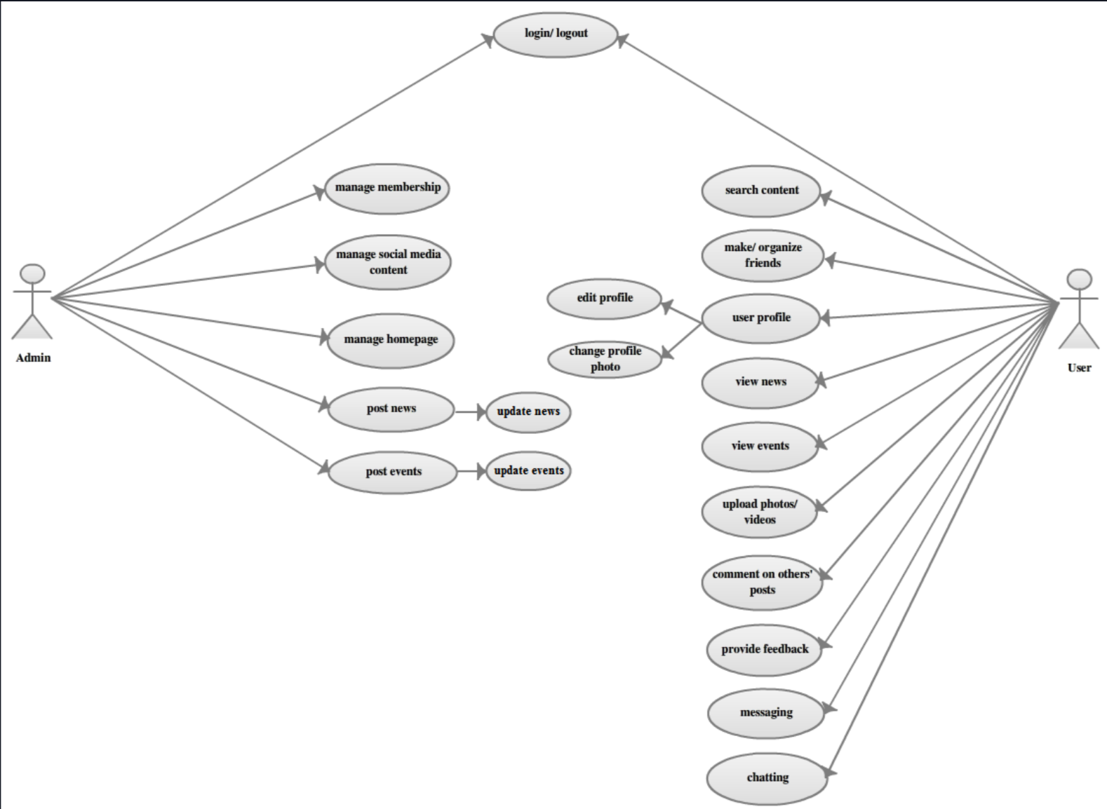

### Testing

* 1. Unit test

| Date | Test Case Name | Test ID | Test Type  (Acceptance, integration or unit test) | Failed/Success Action | Corrective Action | Iterations |
| --- | --- | --- | --- | --- | --- | --- |
| 10/20/21 | Log-In back end testing phase | B01 | Acceptance Test | Failed | Figuring out DJango access | 2 |
| N/A | Front-end and design testing | F01 | Acceptance Test | Success | Continuous tweaking of the UI | 1 |

* 1. Integration test

| Date | Test Case Name | Test ID | Test Type  (Acceptance, integration or unit test) | Failed/Success Action | Corrective Action | Iterations |
| --- | --- | --- | --- | --- | --- | --- |
| 11/20/21 | Front end functions testing | B01 | Integration Test | Success (Unfinished) | Figuring out the final functionality of user interface | 1 |
| N/A | Front-end and design testing | F01 | Integration Test | Failed | Needed more work done to have a running database | N/A |

* 1. N/A
  2. Corrective actions and Iterations

An important step would be to continuously work on setting up the features necessary to get a working database and tweaking the front end UI, so that we have the app functioning close to the final product imagined.

* 1. Graphical Analysis

N/A

### Risk Analysis/Management

First step that has been taken to mitigate any risks that Social Link could produce is to identify where risks could appear in the future. One concern is security and the safety of people’s data. Many problems can arise if a data breach occurs because not only an account on Social Link could be compromised but all accounts attached would also be compromised. A way to take care of this can be an ever updated security system that would be used. This can be contracted out to a company that specializes in cyber security or it can be done in house by programmers on a team.

### Project Schedule

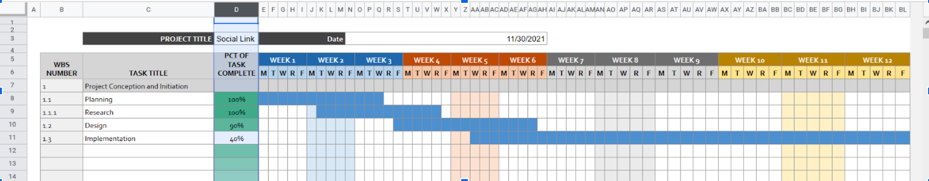

### Cost Analysis and Bill of Material

All software used is currently free or open source.

### Codes, Standards, Constraints

As far as we are concerned we are not infringing on any design patents, rights or conducting any misuse of the product in the time we have worked on this project. As per the IEEE/NSPE code of ethics guidelines we have followed all the guideline rules for developing an ethically acceptable application now in it’s development phase.

Other Standards we will be using include:

**IEEE 802.11x**

Media Access Control (MAC) and Physical Layer (PHY) specifications for the implementation of wireless local area networks. Our Wi-Fi module will connect to the campus network using this standard.

**ISO/IEC 14882**

ANSI C++ standard. Defines the prog

### Conclusion and Future work

There are still many challenges to overcome and lessons to be learned while working on this project. It was quite a large idea in scope when considering the practicality and use of it but we thought it would be fun to tackle that challenge. Much of us was learning a new framework and programming language at the same time while trying to work on this so it was a hurdle to overcome. Time management and coordination were some major factors that we had to learn in order to get as much done as we could when doing this project. And as discussed setting up the database would be a major step in the direction of getting this project running.

### Team-centered behavior & Individual Contributions

We were willing to help each other out when there was a problem that needed to be handled. Much of what we did on the front-end was able to be circled around and worked on in conjunction with the other, which allowed for a consistent design and code. This also applies to the backend side of things.

#### REFERENCES

Jim D.says: et al., “How Many People Use Social Media in 2021? (65+ Statistics),” Backlinko, September 1, 2021, <https://backlinko.com/social-media-users>.

Mao, H., Shuai, X., Kapadia, A.: Loose tweets: an analysis of privacy leaks on

twitter. In: WPES’11. ACM (2011)

#### BIBLIOGRAPHY

Frontend:

Romeo Capozziello: Project Leader, Tech Support

Emmanuelle Deshommes: Team Consultant, Designer

Naseem Davis: Designer

Backend:

Seydou Magassa: Log-in system

Eric Bialczak: Registration System

Olmann : API gatherer

1. Sree Sreeninivasan, “How to Use Social Media in Your Career,” The New York Times (The New York Times), accessed September 22, 2021, <https://www.nytimes.com/guides/business/social-media-for-career-and-business>.